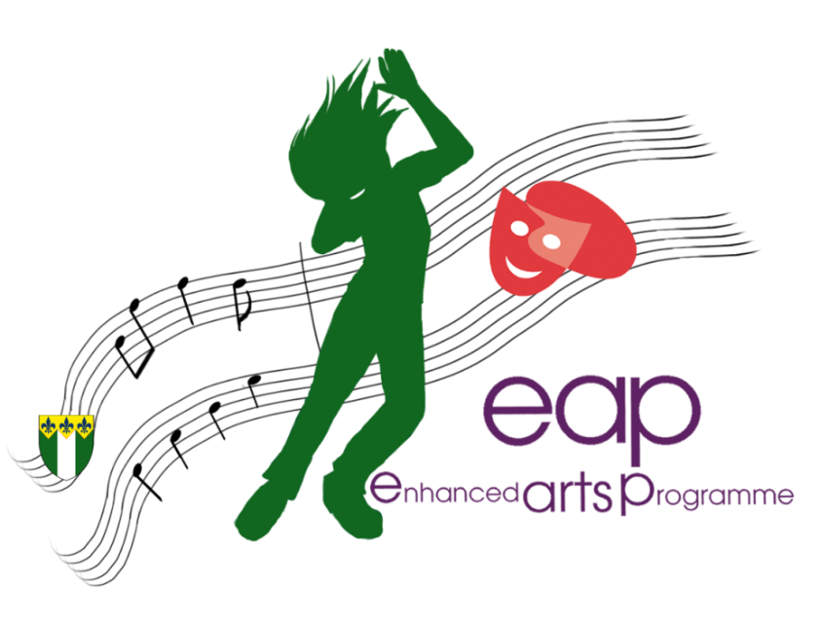
FRIERN BARNET SCHOOL

FOR OFFICE USE
DATE RECEIVED
FIRST REVIEWER
A/D REF.

- You should complete sections A, B, C, and F in full; and sections D, E and G as required.
- completed forms should be returned to the school by post or email:
Address: Main Office, Friern Barnet School, Hemington Avenue London, N11 3LS
Email: eap@friern.barnet.sch.uk

YEAR OF SECONDARY ADMISSION:
Year 5
Year 6
Other – please state ……………….
SECTION A - STUDENT DETAILS
NAME OF CHILD: | DATE OF BIRTH:
PRIMARY SCHOOL ATTENDED:
RESIDENT LOCAL AUTHORITY (IF OUTSIDE BARNET):

SECTION B - PARENT/CARER DETAILS
NAME: Mr / Mrs /Ms / Other (please specify)
EMAIL ADDRESS:
During the application and audition process, information will be issued via email.
Please add eap@friern.barnet.sch.uk to your address book to avoid spam filtering.
If you do not have regular access to email, you should leave this field blank.
DAYTIME TELEPHONE NUMBER:
POSTAL ADDRESS:

POSTCODE:

SECTION C – APPLICATION AND AUDITION DETAILS (please see website for list of audition pieces)
APPLICANT WOULD LIKE TO SPECIALISE IN:  (Choose one, or a combination) | Dance  Drama |  | Music  All-round performing arts
THE ASSESSED SOLO AUDITION WILL BE PERFORMED IN: |  | Dance |  | Drama | Music
TITLE OF POTENTIAL AUDITION PIECE:
INSTRUMENT (IF MUSIC AUDITION):
- Applicants are permitted to change before the day, but we would like an idea of the audition style

- Musical accompaniment for auditions should preferably be provided by the student on a CD. If you require a piano accompaniment, please enclose the sheet music with your application.

- If you require any other resources, e.g. an instrument to play on, please provide details here:

SECTION D – EXPERIENCE Please complete any relevant section(s) in as much detail as possible.
DANCE | Have you ever trained and/or performed as a dancer?  Have you received lessons? Yes No  If yes, who is your teacher, and where do they teach (e.g. Miss Tiptoes, at On Point Ballet School):  How often do you have lessons, and for how long (e.g. 30 minutes, once a week, for six months):  What dance styles have you learned (e.g. jazz, street, tap)?
 | Do you have any performance/concert experience? (Please provide details)
 | Do you have any ensemble experience (e.g. dance troupe)? (Please provide details)
 | Do you have any accreditation/exam passes: (Please provide details)

MUSIC | Instrument(s) played: 1. |  | 2.
FOR YOUR FIRST INSTRUMENT ONLY

Have you received lessons? Yes No

If yes, who is your teacher, and where do they teach (e.g. Mr Sharp, at the primary school):

How often do you have lessons, and for how long (e.g. 30 minutes, once a week, for six months):

 | Do you have any performance/concert experience? (Please provide details)
 | Do you have any ensemble experience (e.g. school orchestra)? (Please provide details)
 | Do you have any accreditation/exam passes: (Please provide details)
SINGING

Have you received lessons? Yes No

If yes, who is your teacher, and where do they teach (e.g. Mrs Reed, at the primary school):

How often do you have lessons, and for how long (e.g. 30 minutes, once a week, for six months):

 | Do you have any performance/concert experience? (Please provide details)
 | Do you have any ensemble experience (e.g. school orchestra)? (Please provide details)
 | Do you have any accreditation/exam passes: (Please provide details)
DRAMA |  | Have you ever trained and/or performed as an actor?  Have you received lessons? Yes No  If yes, who is your teacher, and where do they teach (e.g. Mr Mime, at Straight Face Academy):  How often do you have lessons, and for how long (e.g. 30 minutes, once a week, for six months):  What dramatic techniques have you learned? (e.g. mime, still image, accents)
 |  | Do you have any performance experience? (Please provide details)
 |  | Do you have any solo experience (e.g. monologues)? (Please provide details)
 |  | Do you have any accreditation/exam passes: (Please provide details)

SECTION E – REFERENCES
As part of the selection process we may wish to discuss students’ prior experience and future potential with a teacher from their current school, or someone they have worked with out of school. Please provide details of one or more teachers who could provide a reference relevant to the performing arts.
CURRENT SCHOOL | REFEREE NAME:
 | POSITION WITHIN THE SCHOOL:
OTHER ARTS ORGANISATION | REFEREE NAME:
 | ORGANISATION:
 | POSITION WITHIN THE ORGANISATION:
 | EMAIL ADDRESS:
 | CONTACT TELEPHONE NUMBER:

SECTION F – SUPPORTING STATEMENTS
STUDENT STATEMENT
The pupil applying for the selected place should make their own statement here giving reasons for their interest in the programme and what they hope to achieve if selected.
PARENT/CARER STATEMENT
By applying for selection children and their parent/carers are making a commitment to the Enhanced Arts
Programme. Selected pupils will be expected to work hard and maintain standards in all their regular curriculum subjects as well as the performing arts. The school encourages all students to achieve their full potential and, with those selected, their talents in the arts will be developed to levels of excellence. This will be in the context of the education of the whole child. A partnership between school and home is essential if a student is to succeed to the best of their ability.

Please read the above statement carefully. It is the school’s commitment to those selected. In this section we would like you to make a short statement giving reasons for applying for a selected place and what you are hoping to gain from the Enhanced Arts Programme. Please make your statement below and continue on a separate sheet if necessary.
SECTION G - FEEDBACK
As part of the school’s transformative culture, we highly value feedback from all stakeholders, whatever their experience of engaging with us. We would therefore appreciate it if you could take a few moments to provide the following information. This will not affect the outcome of your application.
HOW DID YOU HEAR ABOUT THE EAP?

School Open Evening School website Friend/family member/word of mouth

Through primary school Through another arts professional

Other (please specify):

How do you rate performing arts provision as a factor in your choice of school?

(Very Important) 1 2 3 4 5 (Not important)

SECTION H - INFORMATION
If your son/daughter is successful in their EAP application and audition we would like to make you aware of the following information:

- Year 7 EAP students receive free one to one music lessons or LAMDA lessons; year 8 onwards parents may choose to pay to continue the lessons. Any exam fees need to be paid by parents.
- All EAP pupils must attend a minimum of two clubs a week and regular attendance is essential, unless through school absence or prior agreement with staff.
- Outstanding behaviour is expected of EAP students at all times.
- We arrange a series of trips and workshops throughout the year – most will be paid for as part of the EAP programme, however some may require additional payment by parents.
- Parents will need to register on ParentPay, as all communication and permissions slips will be emailed this way.
- EAP pupils receive a personalised t-shirt and hoodie that can be worn during dance and extra-curricular clubs and performances.
- EAP pupils are often required to represent the school at various events including Open Evening and Prize Giving
- All EAP pupils are expected to be part of the school production.

